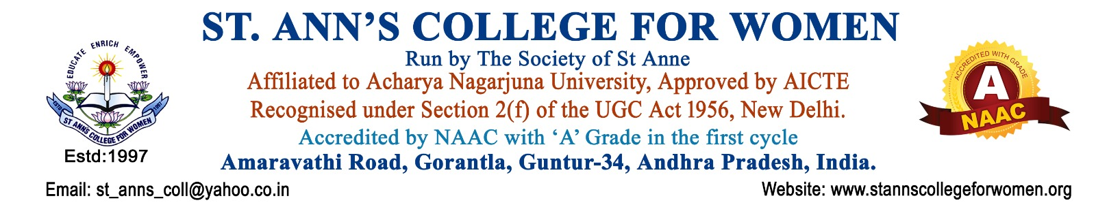

Parents Association Committee
Guidelines, Procedures & Activities
1. Introduction
The Parents Association Committee of St. Ann’s College for Women, Gorantla, Guntur is established to strengthen the relationship between parents and the institution for the holistic development and welfare of students.
The committee serves as an important platform for effective communication, cooperation, and partnership between parents and the college. It functions in accordance with NAAC and UGC quality initiatives to ensure student progress, discipline, academic excellence, and emotional well-being through active parental involvement.
2. Vision
To build a strong and cooperative partnership between parents and the institution for the academic, personal, and social development of students.
3. Mission
- To promote regular communication and interaction between parents and the college.
- To involve parents in the educational and developmental process of students.
- To support students’ academic progress, discipline, and overall well-being.
- To strengthen institutional support systems through parent participation and feedback.
4. Objectives
The objectives of the Parents Association Committee are to:
- Strengthen communication and cooperation between parents and the college.
- Organize regular parent interaction and Parent–Teacher meetings.
- Share students’ academic performance, attendance, behavior, and progress with parents.
- Create awareness regarding institutional rules, policies, academic activities, and student support services.
- Encourage parental involvement in institutional programs and activities.
- Promote discipline, moral values, and positive behavior among students.
- Support the holistic development and welfare of students.
- Build mutual trust and collaboration between parents and faculty.
- Maintain records of meetings, feedback, and communications.
5. Scope of Activities
The Parents Association Committee shall undertake activities related to:
- Parent–Teacher Meetings (PTMs)
- Academic progress review
- Attendance and discipline monitoring
- Counseling and student support
- Parent feedback collection
- Awareness programs for parents
- Student welfare discussions
- Institutional development support
6. Constitution of the Committee
The Parents Association Committee shall consist of:
- Principal – Chairperson
- Parents Association Coordinator / Convener
- Heads of Departments
- Faculty Representatives
- IQAC Representative
- Parent Representatives
- Student Representatives (if required)
The committee composition may be modified by the Principal based on institutional requirements.
7. Roles and Responsibilities
The committee shall:
- Organize regular Parent–Teacher interaction meetings.
- Facilitate communication between parents and faculty members.
- Inform parents about:
  - Academic performance
  - Attendance
  - Discipline
  - Institutional activities
  - Student achievements
- Counsel parents regarding student support and development.
- Encourage parents to participate in institutional events and activities.
- Collect parent feedback and suggestions for institutional improvement.
- Promote a cooperative and supportive learning environment.
- Maintain records and reports of meetings and activities.
8. Procedures
Step 1: Planning of Parent Meetings
- The committee shall prepare a schedule for Parent–Teacher Meetings during the academic year.
Step 2: Communication to Parents
- Parents shall be informed through:
  - Circulars
  - Notices
  - Phone calls
  - WhatsApp groups
  - Institutional communication channels
Step 3: Conduct of Meetings
During Parent–Teacher Meetings, the following shall be discussed:
- Academic performance
- Attendance and punctuality
- Discipline and behavior
- Participation in co-curricular activities
- Student strengths and areas for improvement
- Career guidance and counseling needs
Step 4: Feedback Collection
- Feedback and suggestions from parents shall be collected for quality improvement.
Step 5: Counseling and Support
- Special counseling sessions may be conducted for students requiring academic or emotional support.
Step 6: Follow-Up Measures
- Action taken on parent suggestions and student support measures shall be reviewed periodically.
9. Parent Participation Activities
The committee shall encourage parents to participate in:
- Parent–Teacher Meetings
- Institutional celebrations and events
- Awareness programs
- Student welfare initiatives
- Career guidance programs
- Value-based education activities

10. Student Welfare and Development
The Parents Association Committee shall support:
- Academic improvement
- Discipline and ethical values
- Emotional and psychological well-being
- Career planning and guidance
- Personality development
- Holistic student growth
11. Meetings
- Parent interaction meetings shall be conducted periodically.
- Special meetings may be arranged whenever necessary.
- Minutes of meetings and Action Taken Reports shall be maintained properly.
12. Documentation and Records
The committee shall maintain:
- Committee Constitution
- Parent Meeting Schedules
- Attendance Records
- Parent Feedback Forms
- Student Progress Reports
- Counseling Records
- Minutes of Meetings
- Action Taken Reports
- Photographs and Event Reports
- Annual Reports
13. NAAC & UGC Compliance
The Parents Association Committee functions in alignment with:
- NAAC Student Support and Stakeholder Participation Framework
- UGC Student Welfare and Counseling Initiatives
- Holistic and Student-Centric Education Practices
The committee contributes to:
- Stakeholder Participation
- Student Welfare and Support
- Academic Monitoring
- Institutional Quality Enhancement
- Parent–Institution Collaboration
- Holistic Development of Students
14. Expected Outcomes
The activities of the Parents Association Committee are expected to:
- Strengthen communication between parents and the institution.
- Improve academic performance and student discipline.
- Enhance parental involvement in student development.
- Promote mutual trust and cooperation.
- Support emotional and academic well-being of students.
- Contribute to holistic and value-based education.
15. Conclusion
St. Ann’s College for Women, Gorantla, Guntur is committed to fostering a collaborative relationship between parents and the institution for the welfare and holistic development of students. The Parents Association Committee plays a vital role in strengthening communication, promoting student support systems, and enhancing institutional quality in alignment with NAAC and UGC standards.

